A Healthier You!

***Learn from Experts that Educate, have the Credentials & Deliver!***

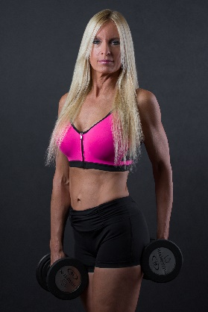



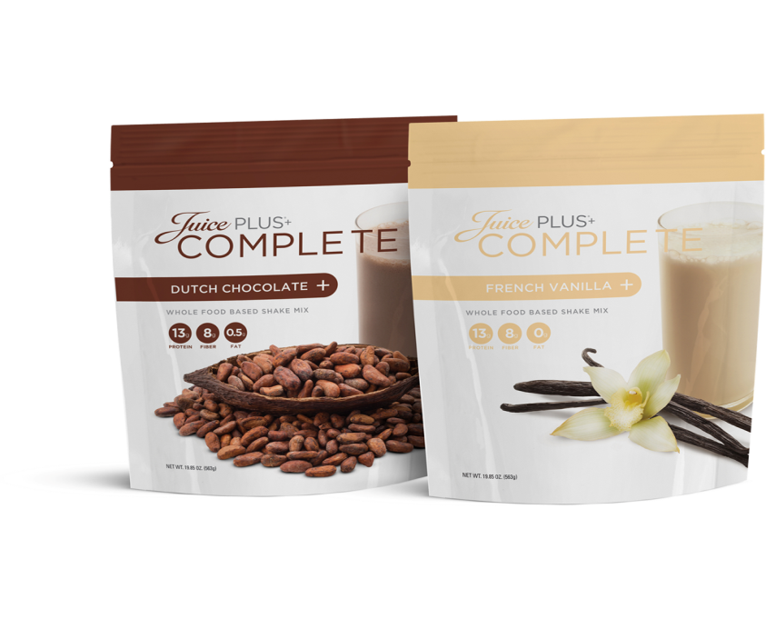

**Dr. Cynthia Dilauro, *Medical Doctor* & Valerie Early, *Registered Dietitian***

* **Improve your overall health, body fat, and weight!**
* **Long term sustainable, EASY & affordable PROGRAM!**
* **Following the lecture, stay to learn how to get 4 years of Free nutritional products for kids and time and money freedom!**

**Free Event! Wednesday, July 13th, 2016 at 7:00 pm**

**Seating is Limited! RSVP Required! 330-929-3539**

**Location: Dr. Cynthia Dilauro’s Office, 739 Graham Rd, Cuyahoga Falls**

[**www.cynthiadilauro.juiceplus.com**](http://www.cynthiadilauro.juiceplus.com)