Manage Moods & Depression

Be informed about all your choices with the most health affects NOT side effects.
Did you know…….
- Major depressive disorder is the leading cause of disability between the ages of 15-44!!
- Exercise can help anxiety and depression if chosen properly for each condition.
- Anxiety disorder is the most common mental illness in the United States.
- You can test your neurotransmitters like serotonin & dopamine…. (at ALL ages) to help you choose the best over-the counter, (OTC), lifestyle, nutrition or pharmaceutical treatments?

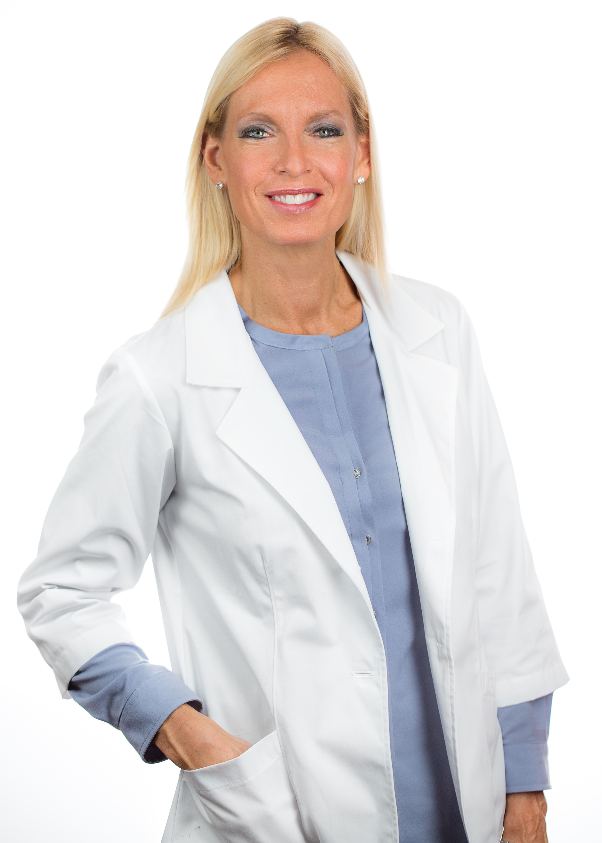

Valerie Early, R.D., L.D.N, R.Ph.T.
Author, International Motivational Health Speaker, Registered & Licensed Dietitian, Registered Pharmacy Technician, Certified Medical Exercise Specialist, Reiki Master, NMD
www.nutritionconnectionbalance.com

Date: November 2nd, 2016

Time: 7:00pm - 8:30pm

Location: Midtown Athletic Club
1760 N. Hicks Rd., Palatine, IL
RSVP: 847-985-1200 or
Rosanne@nutritionconnectionbalance.com

