Exercise, Performance & Nutrition
For Athletic Children, Trainers, Coaches & Exercisers
Featuring: Valerie Early, RD, LDN, R.Ph.T. Medical Exercise Specialist

Are you practicing and intaking the optimal nutrient dense fuel and refueling after hard workouts, training and competitions?

** Stay up to date for yourself, your clients and athletes! **

Learn more about research based whole food products, shakes and supplements to protect you and your clients from the oxidative stress that you produce during intense training and exercise. Learn more about the Nutrition and Food based science that can give you the edge, help protect you from injuries, fatigue, anemia, arthritis and tissue degregation, menstrual changes and depression.

**Don’t believe all the product marketing hype, get the **
science and fact based information!

Date: May 5th, 2016
Time: 7:00 pm-8:30 pm
Location: Crowne Plaza Hotel ~ 5300 Rockside Rd. ~ Independence, OH 44131
Please Register Online: http://tinyurl.com/valfit
GUESTS FREE Reps $15 in advance/$25 at the door

- Valerie Early, RD is a 1993 graduate of Florida State University.
- She is a Registered and Licensed Dietitian Nutritionist, Registered Pharmacy Technician, a Certified Medical Exercise Specialist, NMD and Reiki Master.
- “Nutrition, Connection, Balance” in Illinois is her private practice; specializing in sports nutrition and hormones for over ten years.
- She has competed in two natural bodybuilding shows & three marathons & thrives on working with athletes.
- Valerie has raised 5 athletic children with her decathlete partner.
- She is author of a book called 8 Ways to Lose Your Blubber through Hormone Balancing and Lifestyle, has an audio CD and three videos. www.nutritionconnectionbalance.com
- Valerie turns 50 this year! It’s NEVER too late to become active to change your body, brain, bones and aging destiny!
- Bring friends, your athletic children, fellow athletes, coaches & trainers!
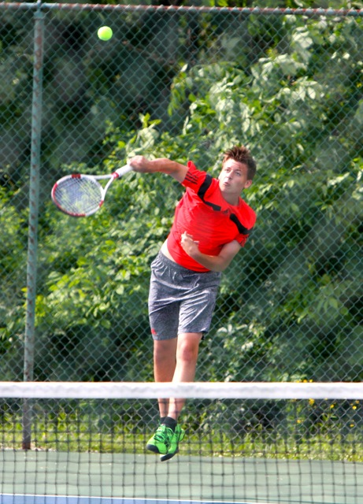
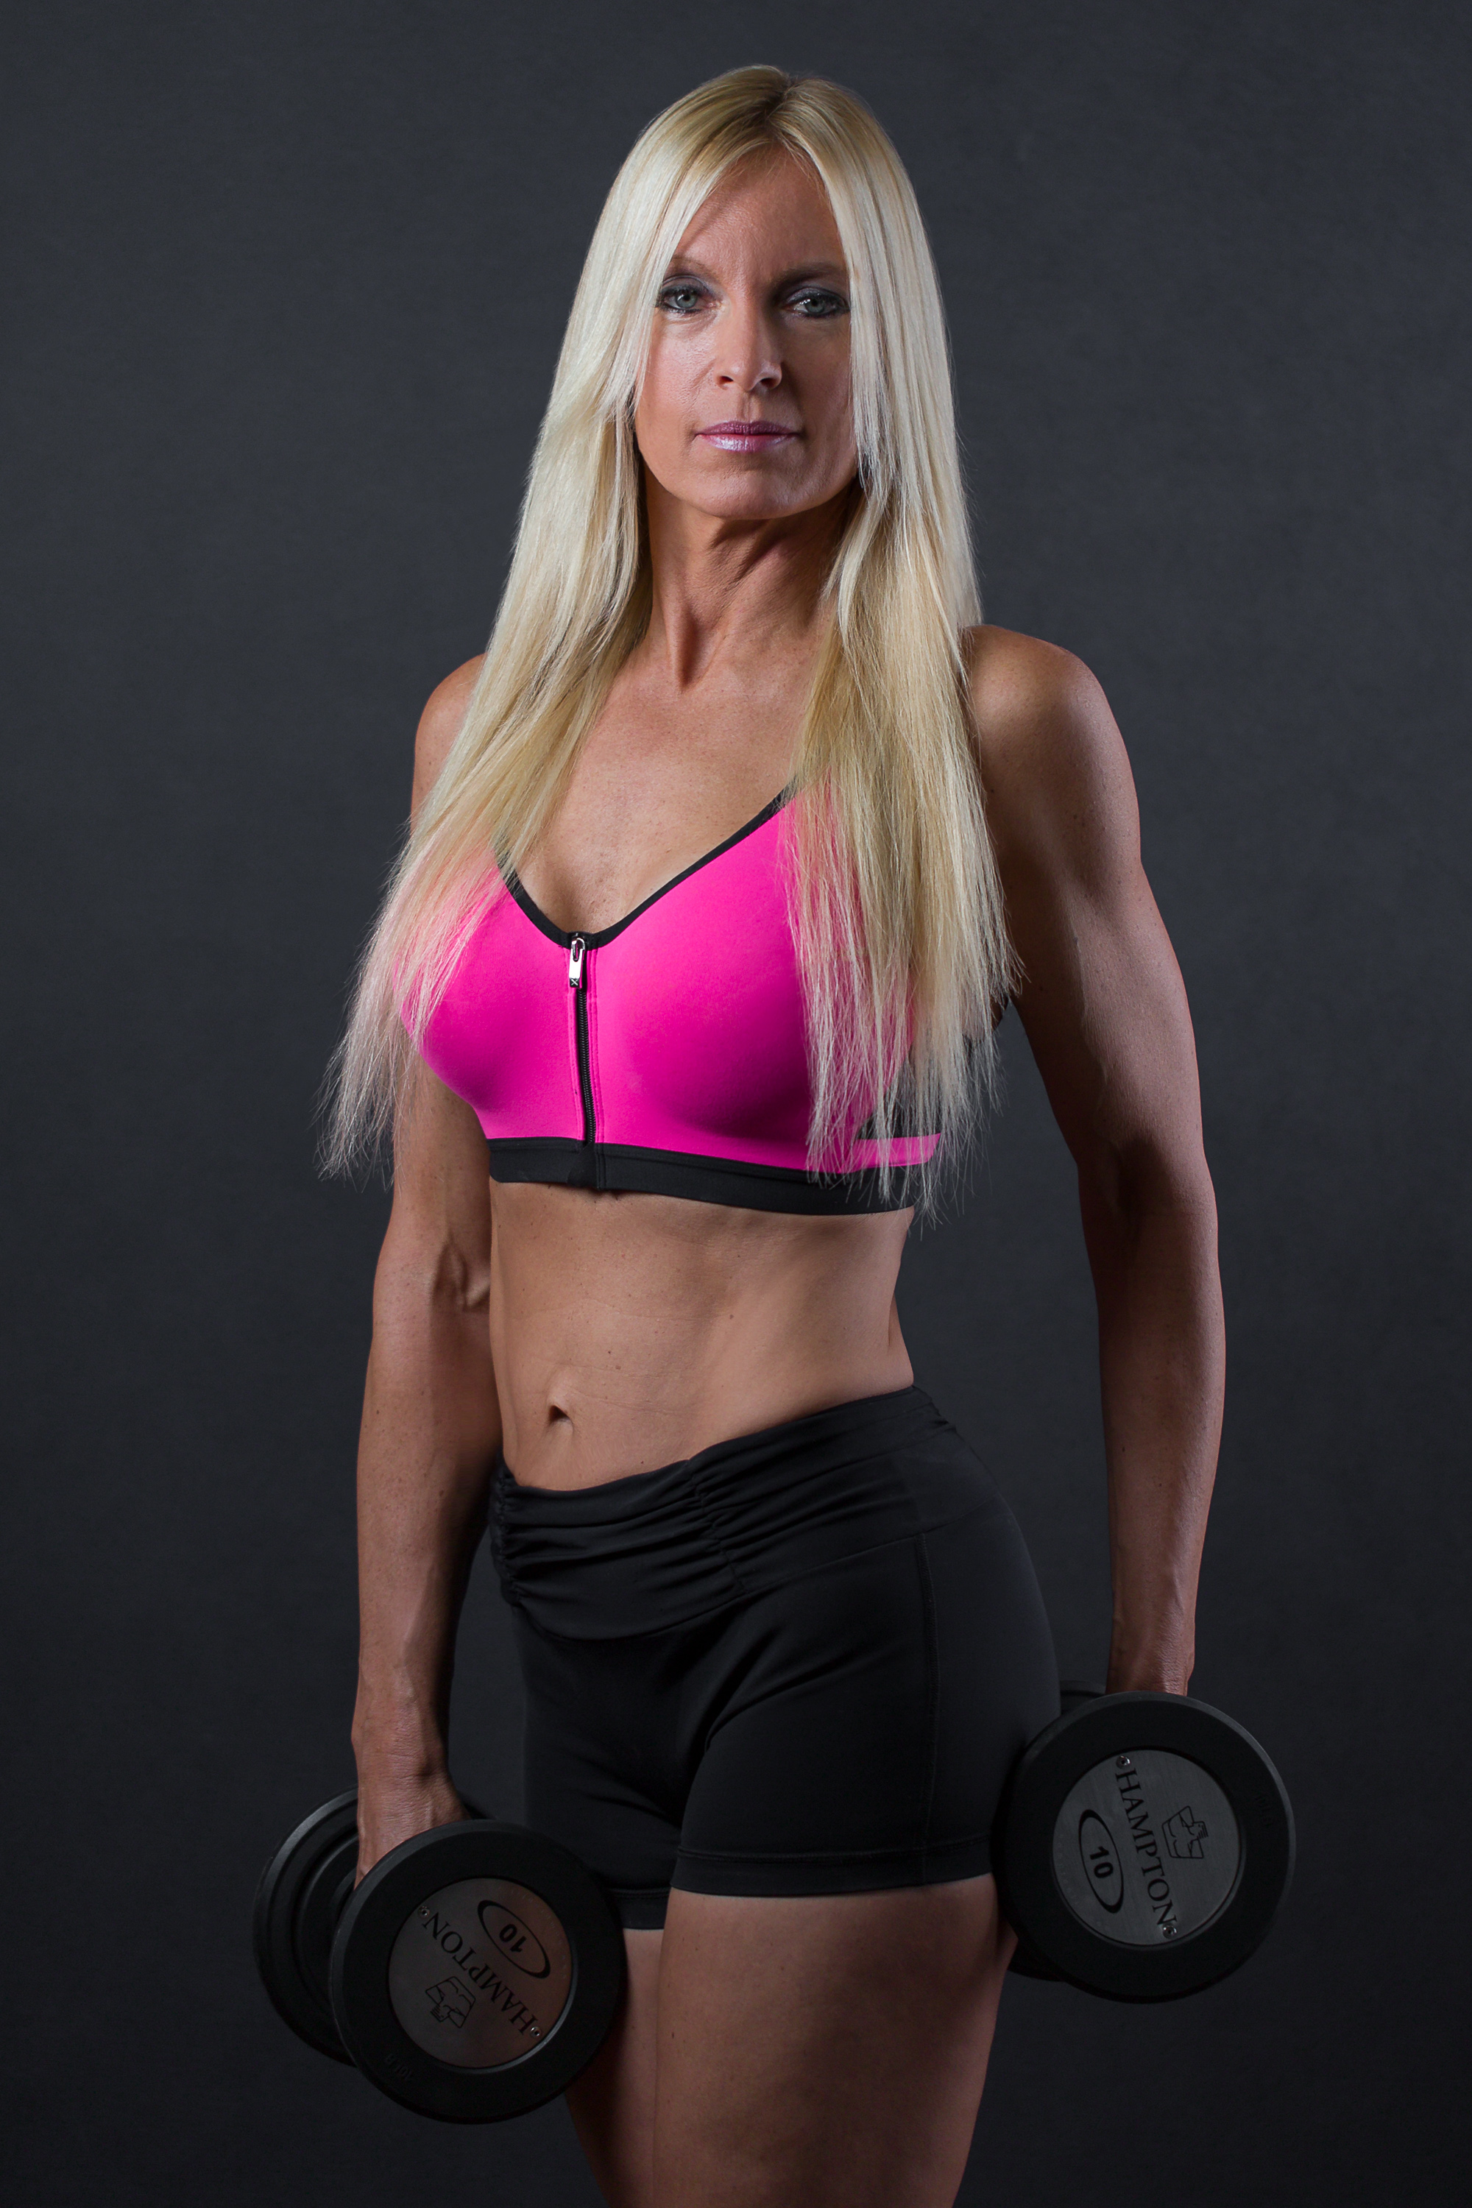 Valerie Early

Valerie Early, RD, LDN, R.Ph.T

