“Endless Energy!!”
Do You Have It?? You Deserve It!
This surprising session will weave you through the causes and solutions of fatigue, apathy, low motivation, low sex drive, weight gain & stress! Learn the ways to address these symptoms and obtain and experience a vitality others will notice and admire!

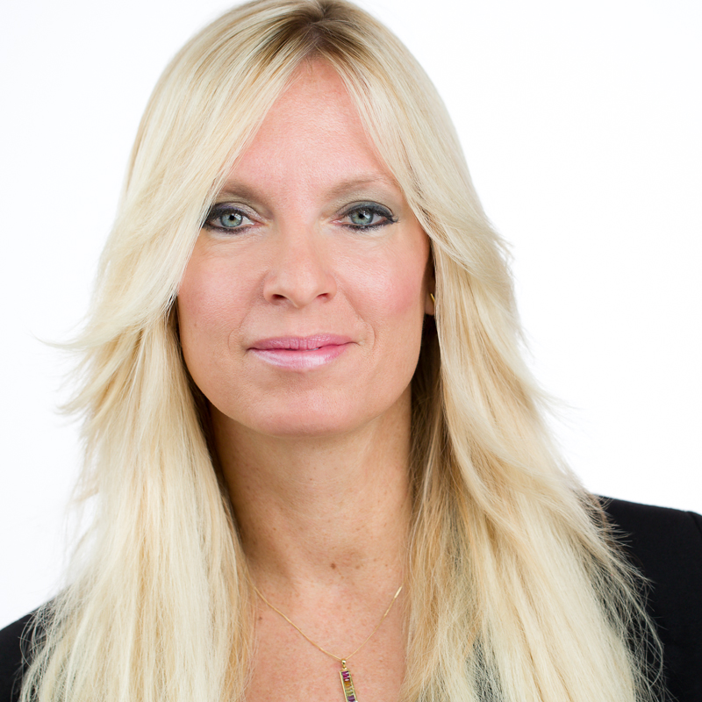
- Understand how to de-stress and have a renewed passion for life!
- Learn how simple lifestyle changes can profoundly improve your energy!
- Learn what to test and why based on your new quest for ZEST!
- Learn specific therapies, food and supplements that can change and improve your life, energy and vibration!

Valerie Early, R.D., L.D.N, R.Ph.T,
Certified Advanced Medical
and Exercise Specialist &
Reiki Master, N.M.D.

Valerie is a Registered and Licensed Dietitian. She will inspire and empower YOU and your FAMILY to feel better and get better with age! Her nick name is “The Energizer Bunny!”

Valerie Early specializes in hormone balancing, preventative techniques, energy medicine and sports nutrition in her private practice, Nutrition, Connection, Balance (NCB) in Schaumburg, Illinois. She provides advanced assessments for nutrition, stress, and hormone related health challenges for men, women and teens which result in individualized, integrative management plans that elevate one’s vitality and life! Valerie is the author of the book, “8 Ways to Lose Your Blubber through Hormone Balancing and Lifestyle Changes” and has an audio CD, “Renew Your Life Through Hormone Balancing “as well as 3 professionally taped videos! www.nutritionconnectionbalance.com

Date: July 12, 2016
Time: 7:00 pm
Place: Midtown Athletic Club, 1760 N. Hicks Rd, Palatine, IL
Guests are FREE if you RSVP to 847-985-1200 or Rosanne@nutritionconnectionbalance.com

