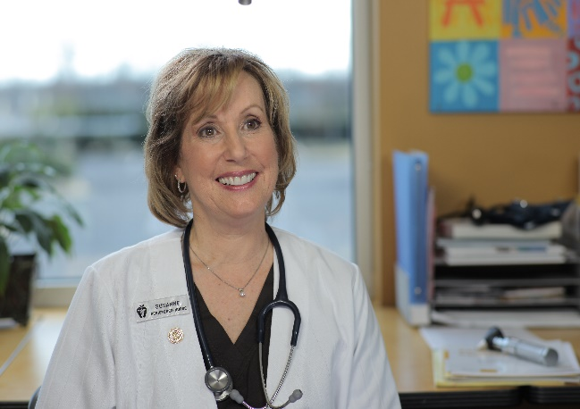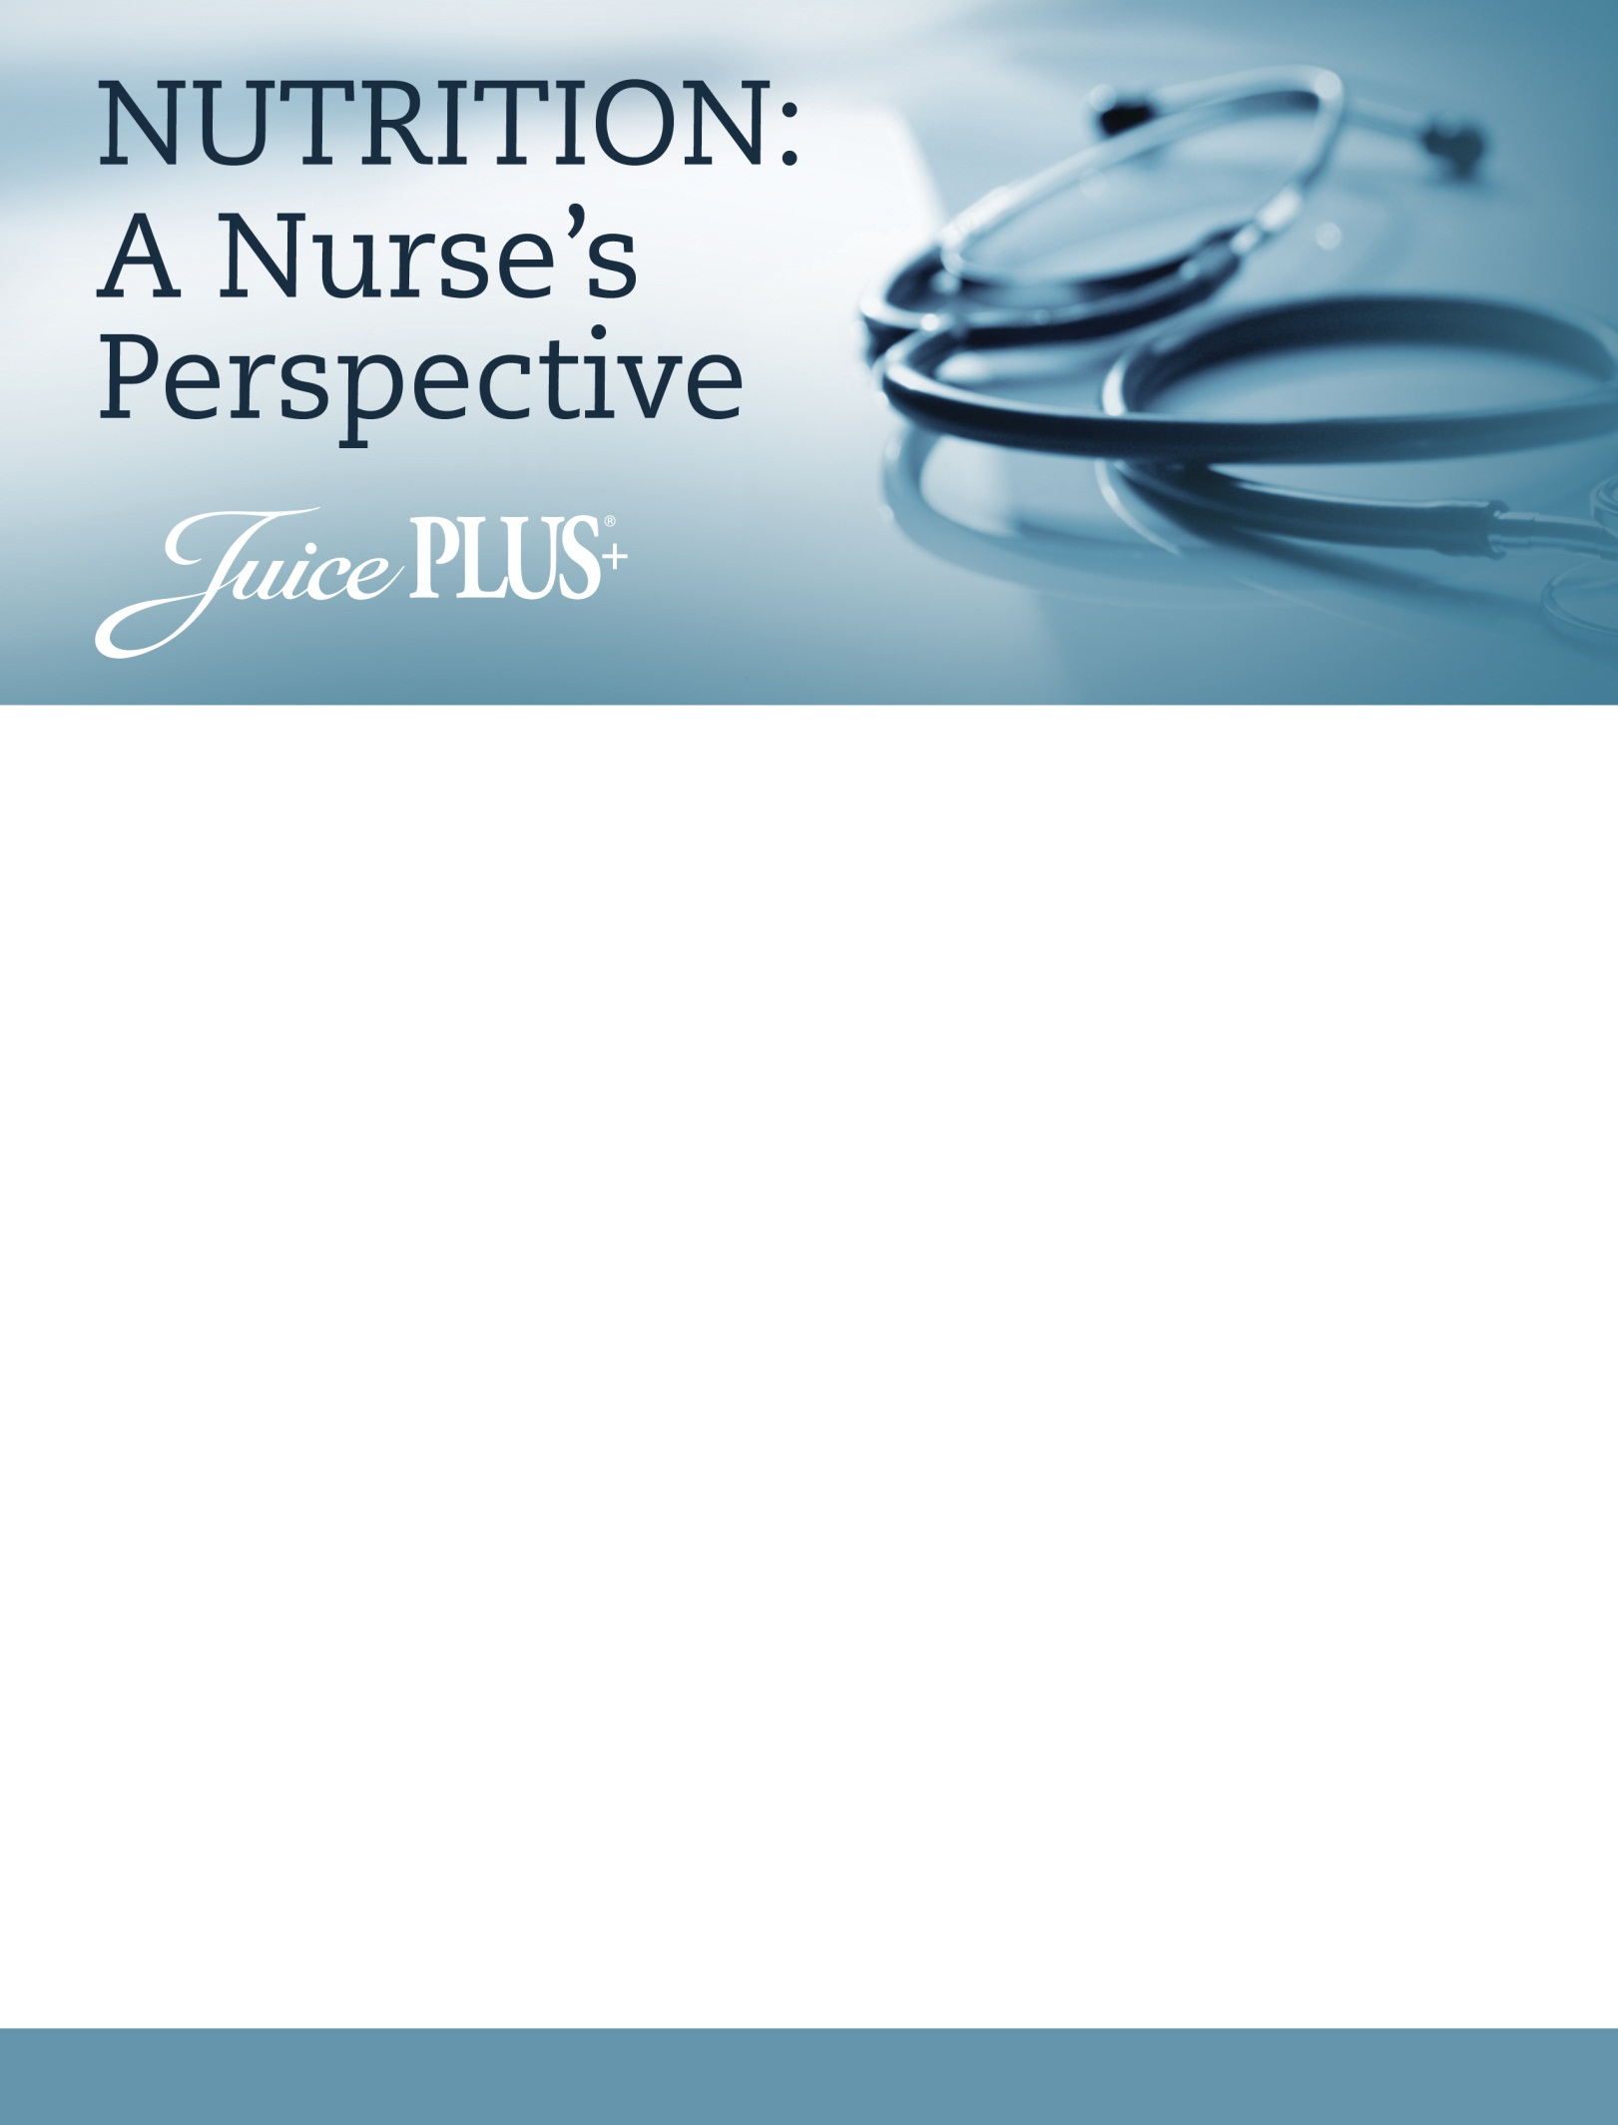

**JOURNEY TO WELLNESS**

**Susanne Edson RN** has been a Registered Nurse for

over 30 years specializing in Neo-Natal Intensive Care

at Grady Memorial Hospital and Children’s Emergency Room at Scottish Rite Children’s Hospital, Atlanta, GA.

In 1996 she was introduced to Juice Plus+, whole-food based nutrition, thus began her focus on and journey to wellness. In 1998, Susanne left her nursing job at the hospital to join the Wellness Industry and share the importance of healthy eating, healthy living and prevention with her two young daughters at her side.

*“The simplicity of Juice Plus+ has benefited my family and friends who have added Juice Plus+ to their diet.”   
 Susanne Edson RN*

**Wednesday, April 6, 2016 ~ 7PM**

**Crystal Lake Holiday Inn**  
**800 S. Rt. 31; Crystal Lake, IL 60014**

Free for Guests & Co-op Members - $15 for JP+ Educators

To Register: call Rosanne @ 847-985-1200 or

Email: Rosanne@nutritionconnectionbalance.com

You are invited to join us after the health talk to learn about the Virtual Franchise  
 and the company with a heart behind Juice Plus+