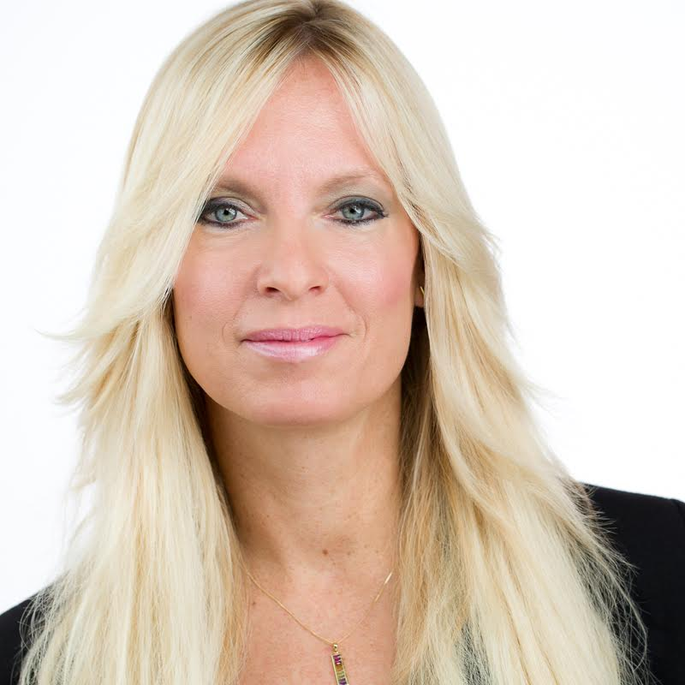

**Required RSVP to:**

**Rosanne**

**847-985-1200**

**www.nutritionconnectionbalance.com**

**Thursday, December 17th, 7:00pm**

**YOUniversity Education Room**

**1443 W. Schaumburg Rd. Suite 22**

**Schaumburg, IL 60194**

**Valerie Early, R.D., L.D.N, R.Ph.T,**

**ACE Certified Medical Exercise Specialist & Reiki Master**

**Valerie thrives on empowering people to embrace health, nutrition and exercise. She motivates, inspires, and provides easy, clear tools that allow people to achieve their personal wellness and vitality goals. Valerie is also a registered pharmacy technician, a certified advanced health and fitness specialist. She received her BS degree in Food and Nutrition Science from Florida State University and completed her Medical Nutrition Internship at the Cleveland Clinic Foundation.**

**Valerie's extensive clinical experience expands from working with professional and non-professional athletes to improve their energy, increase strength and stamina, and have fewer injuries. She has been a past director of a compounding pharmacy and currently owns her integrative nutrition practice for over nine years. She specializes in working with men, women, and children with nutrition, hormonal and neurotransmitter imbalances. Her infectious energy will spread to you and you guests. Valerie is a Mom of two sons. She has competed in two natural bodybuilding competitions and has run three marathons. Don't miss this "Energizer Bunny", author, motivational speaker and integrative nutritionist!**

 Understand how to de-stress and

have a renewed passion for life!

 Learn how simple lifestyle changes

can profoundly improve your

energy!

 Learn what to test and why, based

on your new quest for ZEST!

 Learn specific therapies, food and

supplements that can change and

improve your life, energy and

vibration!

**Live a Life of Abundance**

**Health and Energy**