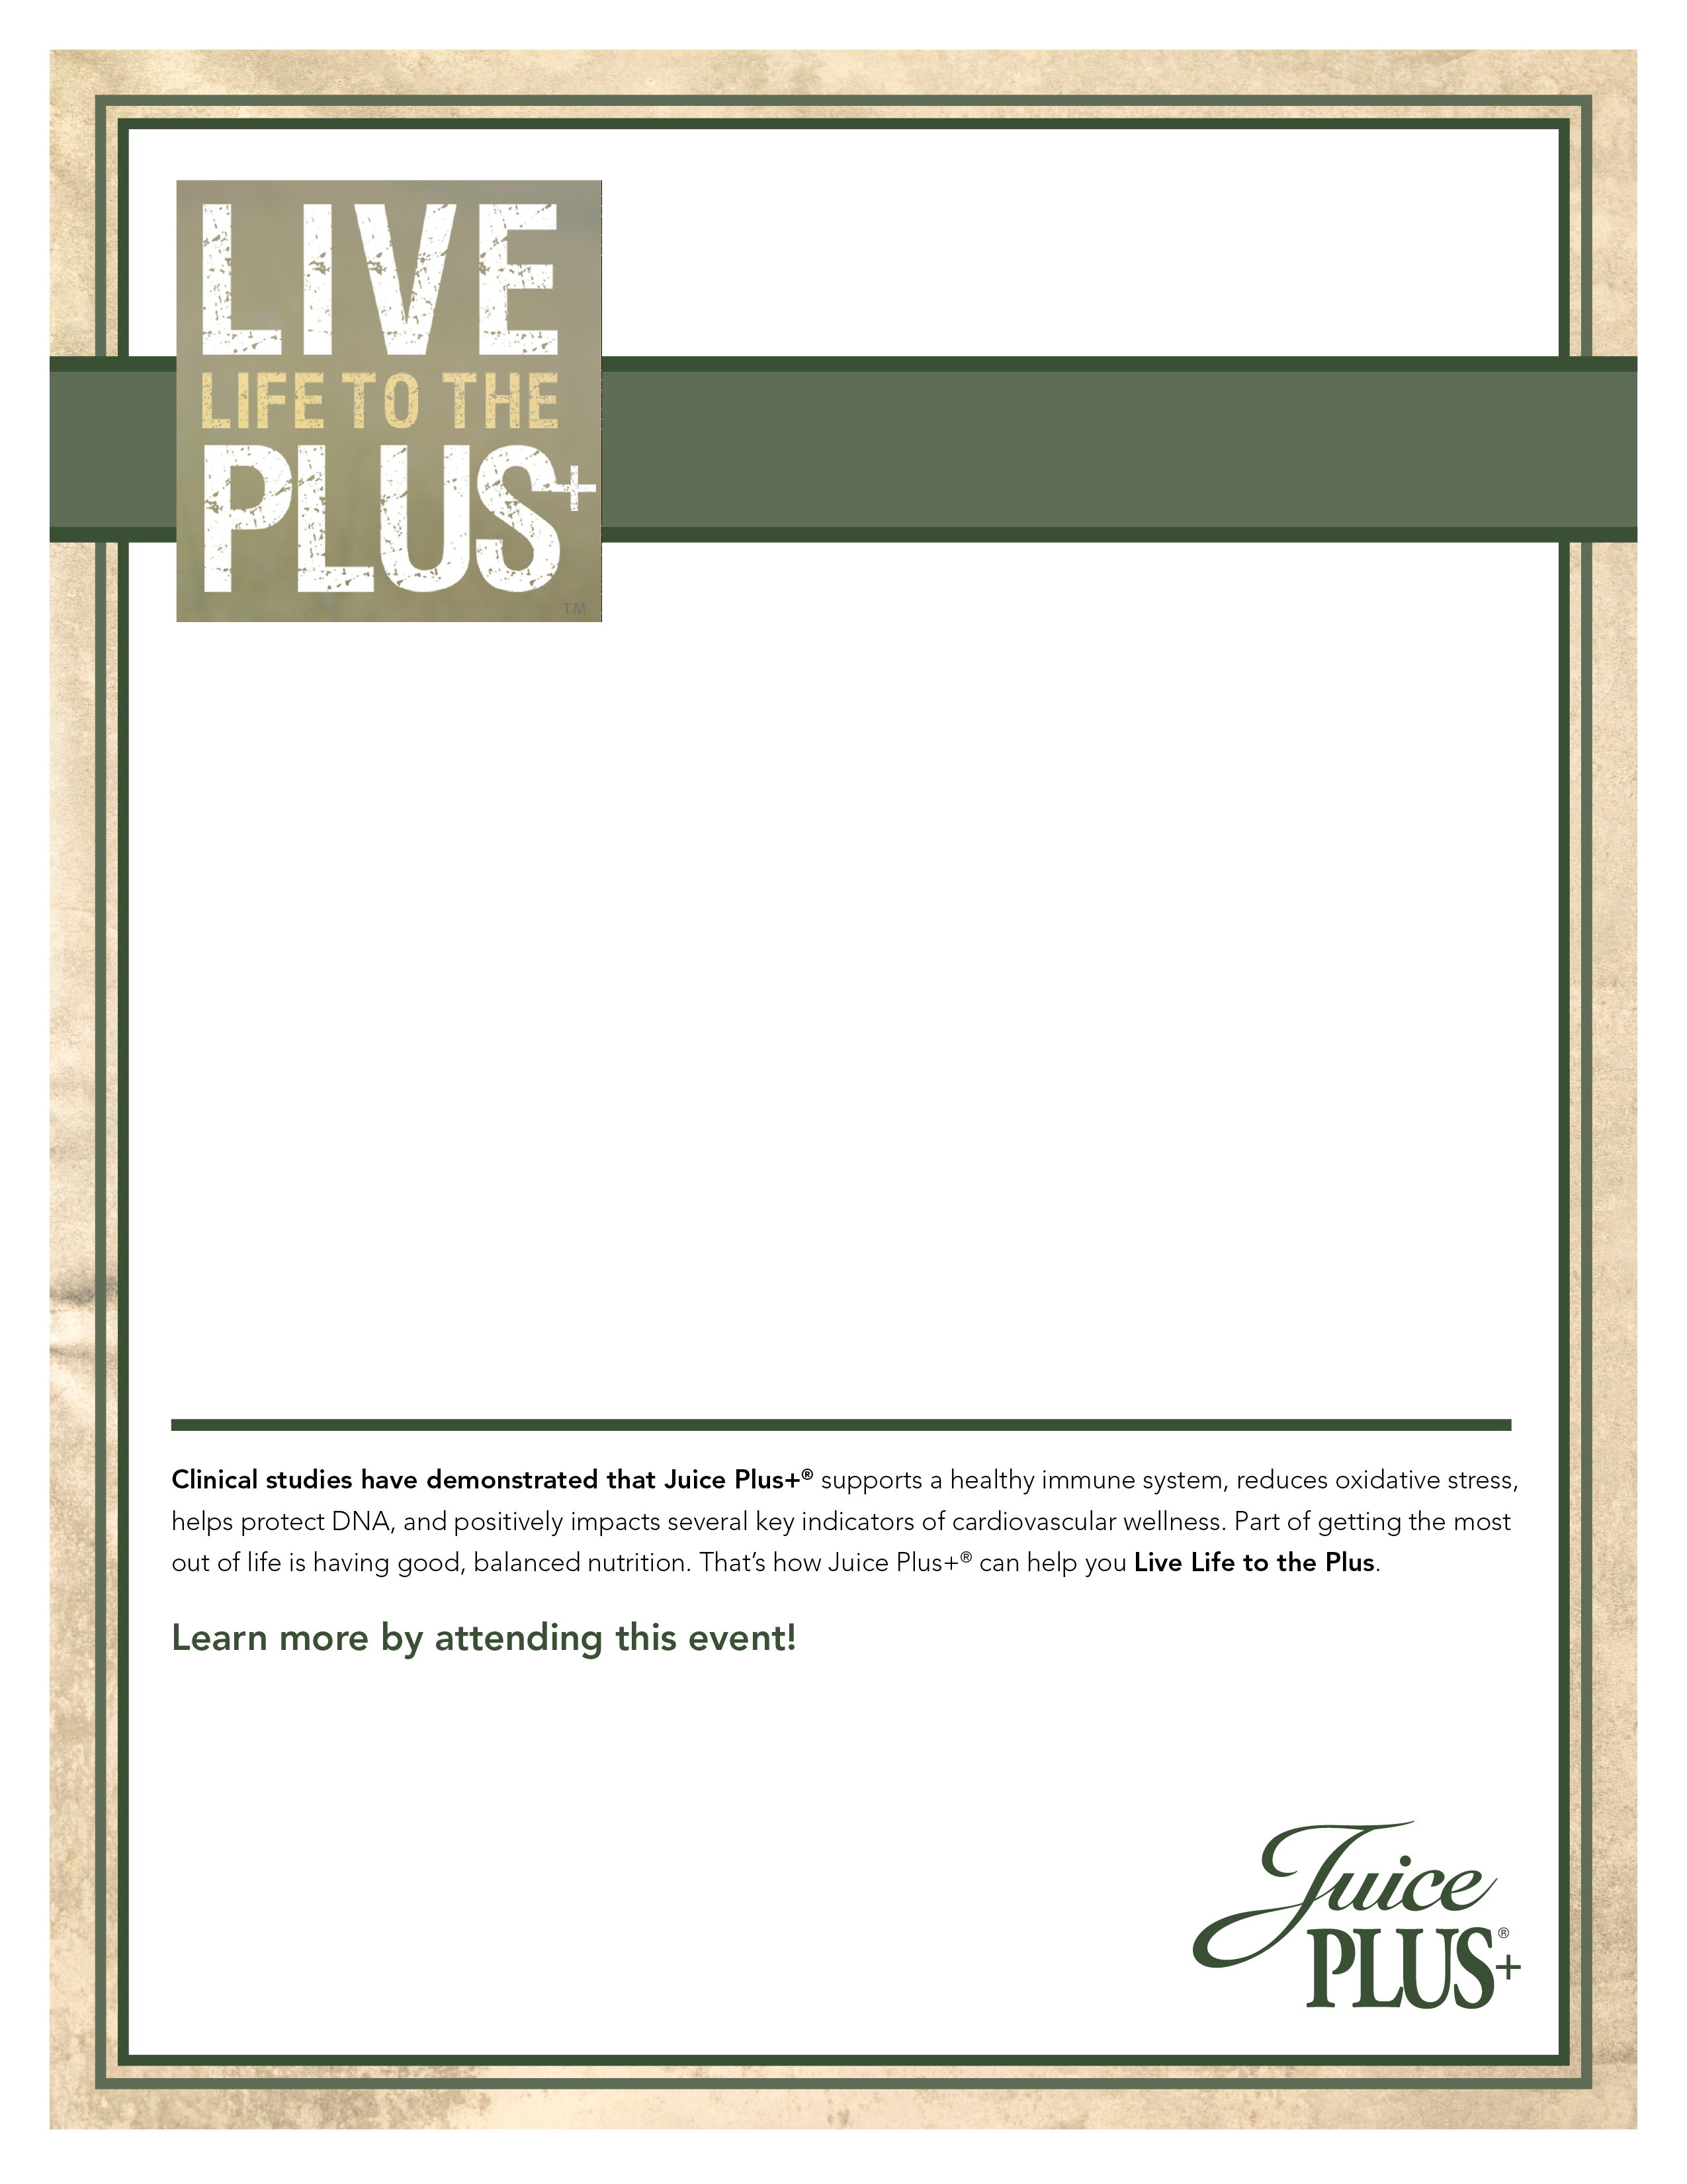

Wednesday, November 18, 2015 – 7:00PM
Hyatt Lisle
1400 Corporetum Drive; Lisle, IL 60532

Guests & Co-op members are Free, $15 for JP+ Representatives
To register: call Rosanne @ 847-985-1200
Sponsored by Prevention Chicago

Essential Nutrition for the 21st Century:
What Everyone Deserves to Know

Candace Corson, M.D.

- Graduate of Yale University School of Medicine 1976
- Chief Resident, Family Medicine Residency at University of Rochester, NY 1978-89
- U.S. Public Health Service, non-commissioned officer, National Health Service Corps, 1980’s serving in rural North Carolina
- Medical Consultant in Integrative Medicine, 1990’s, at the Healing Arts Center on the River in Mishawaka, Indiana
- Past 15 years working in Prevention, Integrative Medicine and Chronic Illness Improvement or Reversal
- Medical Editor: Medicinal Plants of North America, by Jim Meuninck (Pequot Press 2008)
- Frequent lecturer nationally on health, environmental illness, and the role of nutrition in fitness, mental & physical performance, health improvement & recovery, in kids & adults.


